RUN XAMPP

Then open CMD, change cmd location to C -> xampp -> mysql -> bin

Connect with mysql

Mysql –u root –p –h localhost

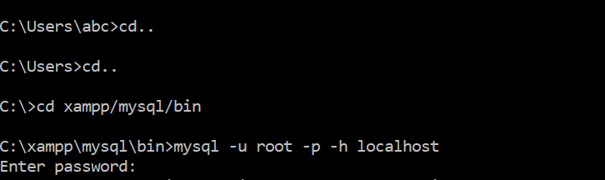

To get all database:

show databases;

Then in browser,

localhost/phymyadmin

How to create database:

create database mysql1;

To use newly created database:

use mysql1;

To check which database is using:

select database()

How to delete database:

drop database mysql1;

Datatypes in mysql:

Numerica, string and data/time

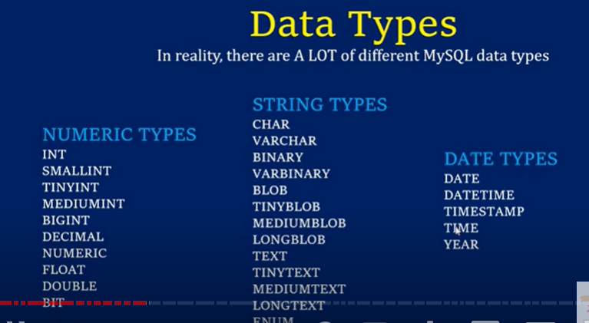

TABLE:

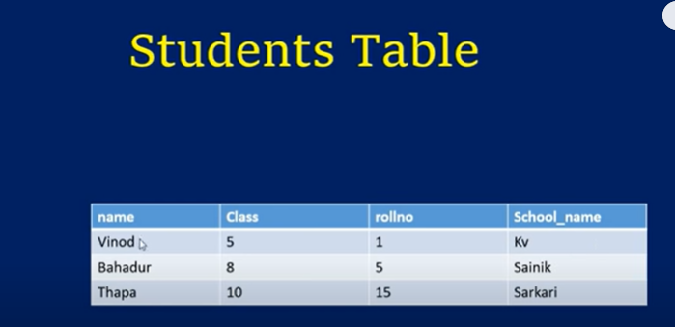

Columns -> fields

Rows -> Records

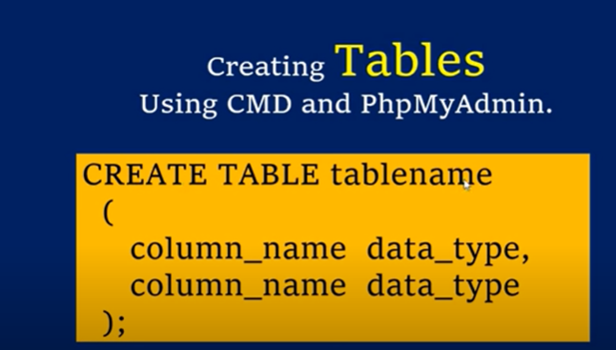

In above, 4 fields and 3 records

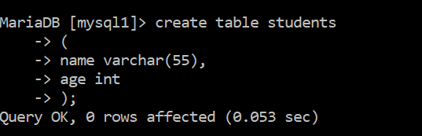

To check no of tables in a database:

Show tables;

To check no of fields in a table or to check columns of table or to check description:

desc students

OR

show columns from students;

to delete Table:

drop table students;

How to insert data into tables:

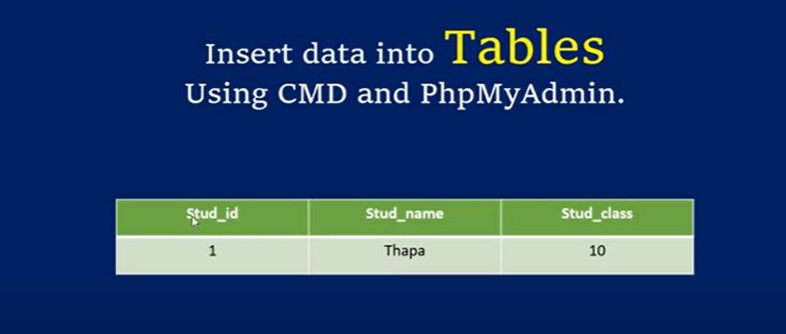

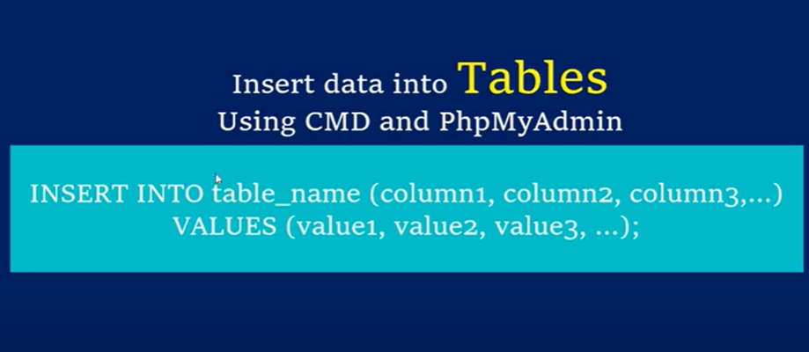

First Method (By specifying columns):

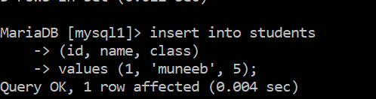

Second Method (Without specifying columns)

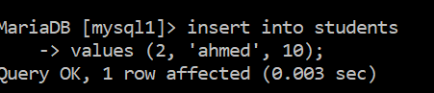

To get all table data or to show all table data:

select * from students

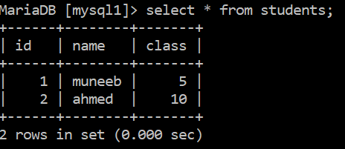

It can insert data into table of wrong data type, like id is of int, but we have passed string in id field but with warning

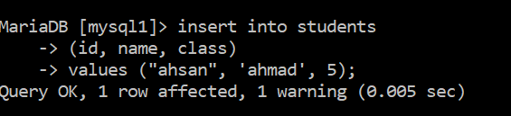

Now we need to see warning

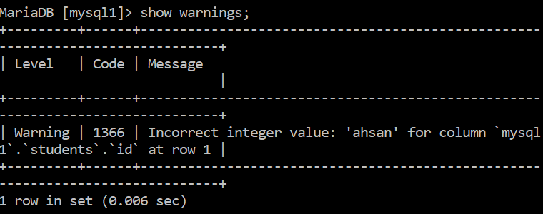

Not null fields in table:

To make sure every field show have value, we assign field not null when creating a table

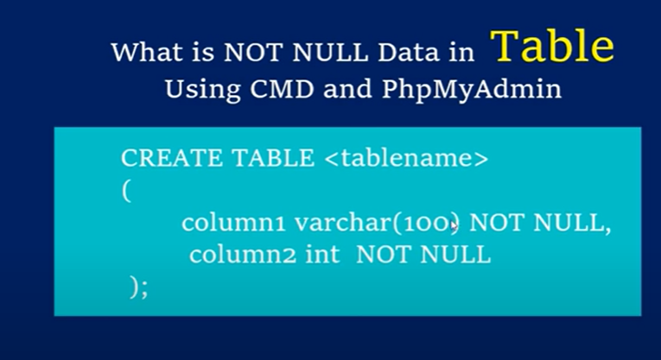

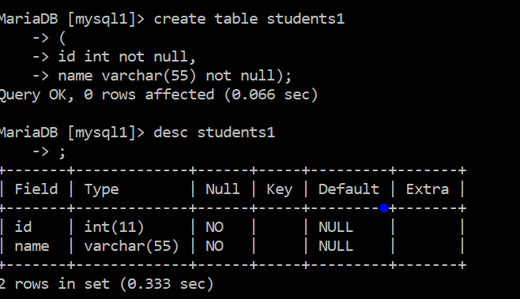

Now we don’t pass any value in field id, so it will automatically assign value as it should not be null

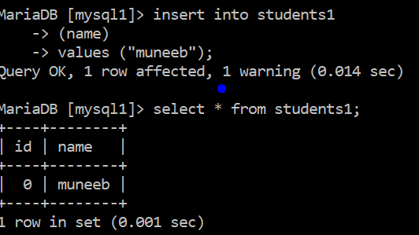

As it automatically gives value, we can also give some default value at the time of creation of table

Default field value:

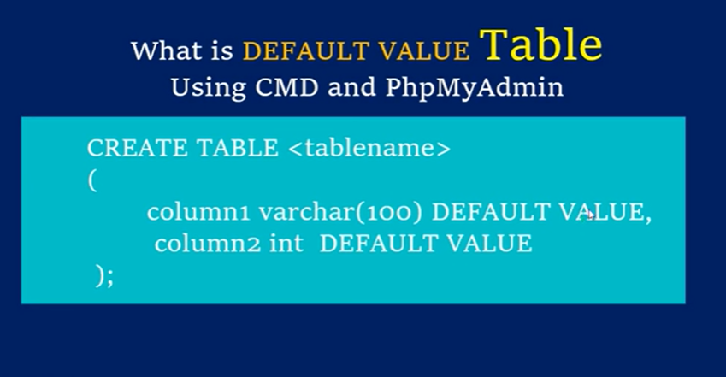

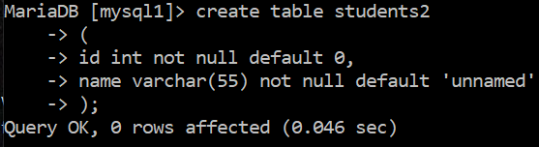

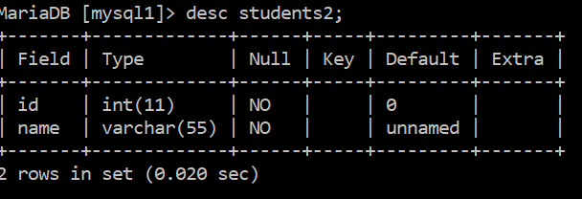

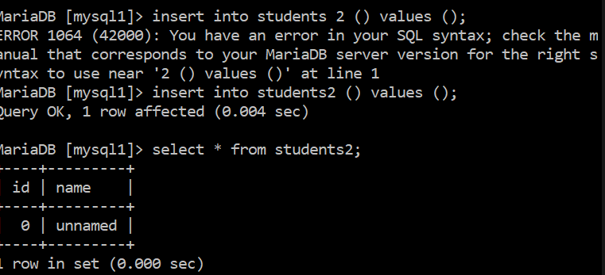

To add/delete

extra column in an older table:

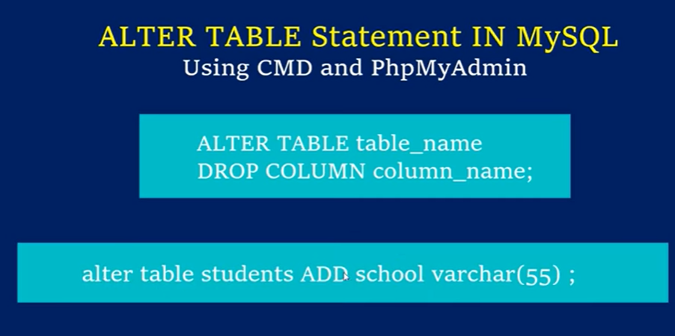

Primary key:

Primary key:

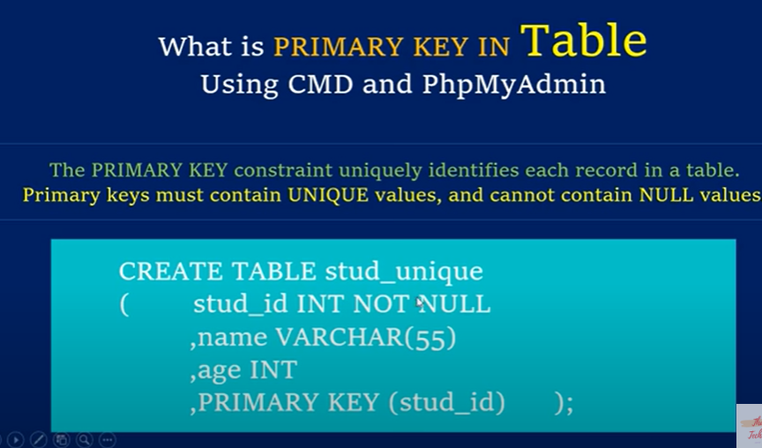

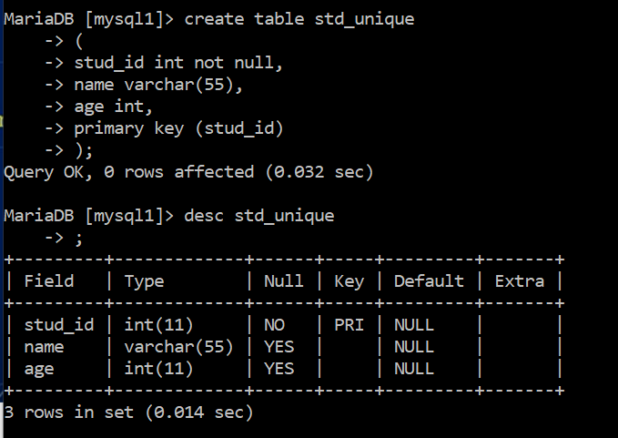

Autoincrement (EXTRA):

Mostly uses with primary key, and primary key mostly uses with id as it is unique for all records



As we are incrementing id by 1, like first record has 1 , then second has 2 etc, we can automatically generate incremented id with the help of auto increment

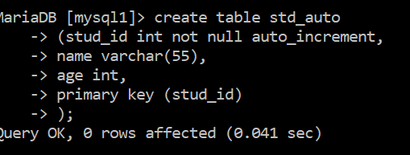

Now next time when we insert field into table, it will automatically increment value to which autoincrement assigned

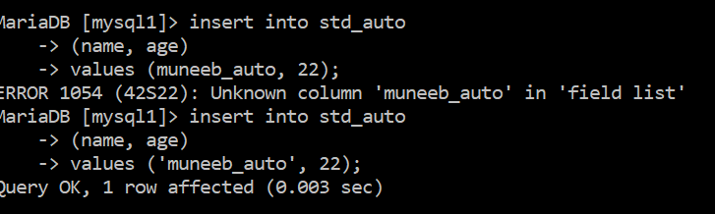

As we have not assigned std_id any value, and we have placed auto increment with it, so its value will automatically increased by 1

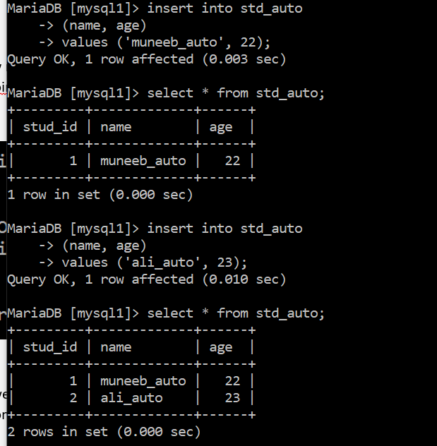

It has automatically incremented a value

CRUD

Creat and Read, also how to add multiple records at once:

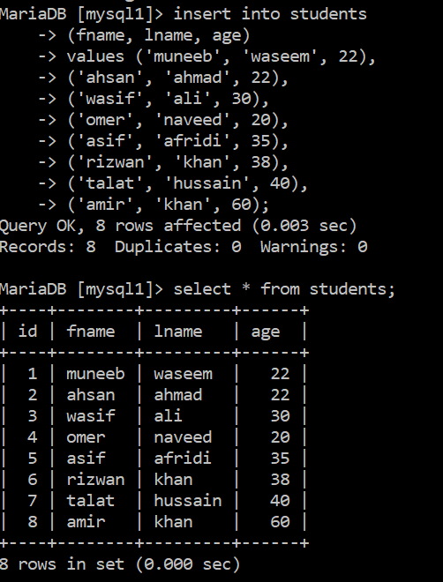

Where clause:



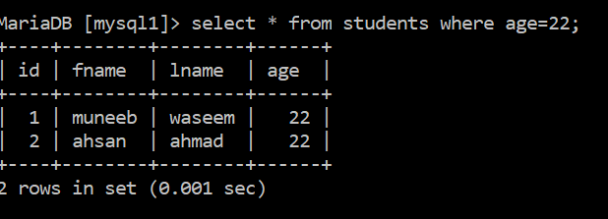

To get cetain column or columns or fields:

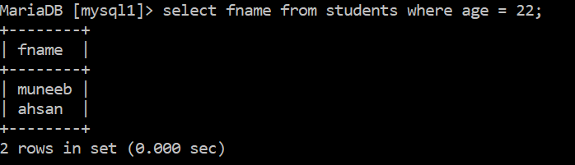

Update:

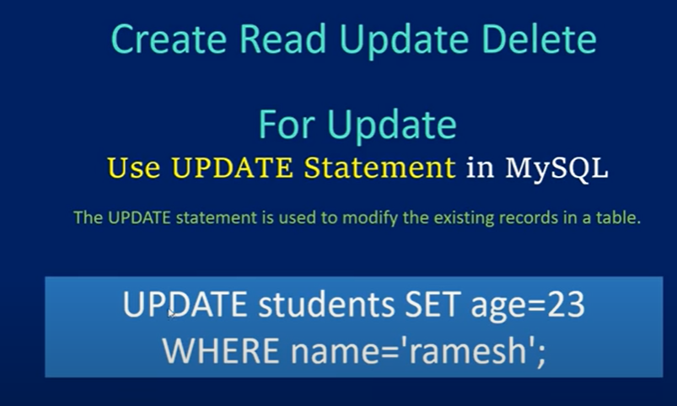

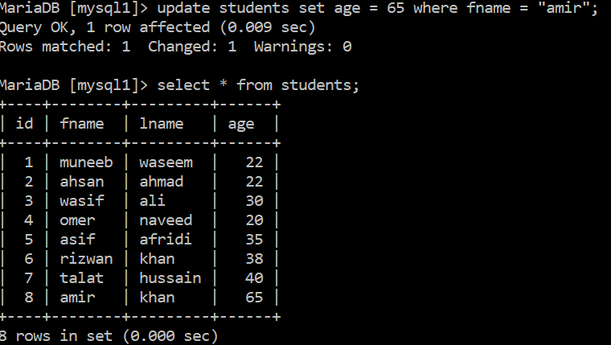

Delete:



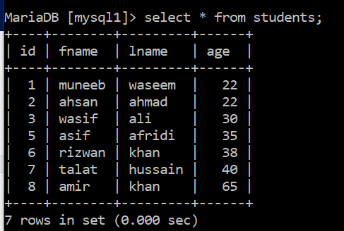

Distinct statement:

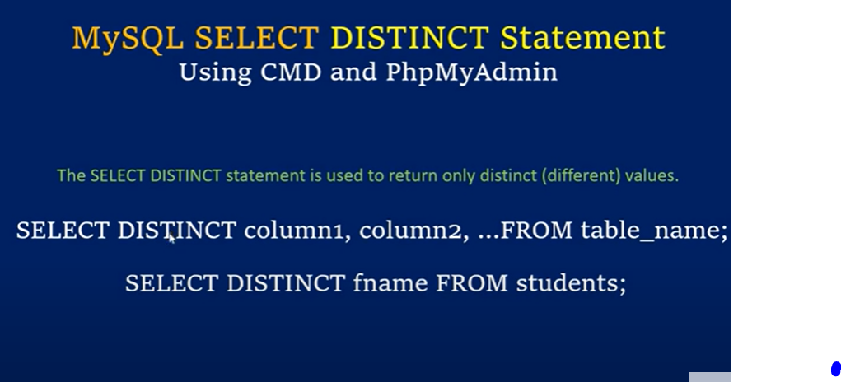

It will only gives unique values of selected field or column

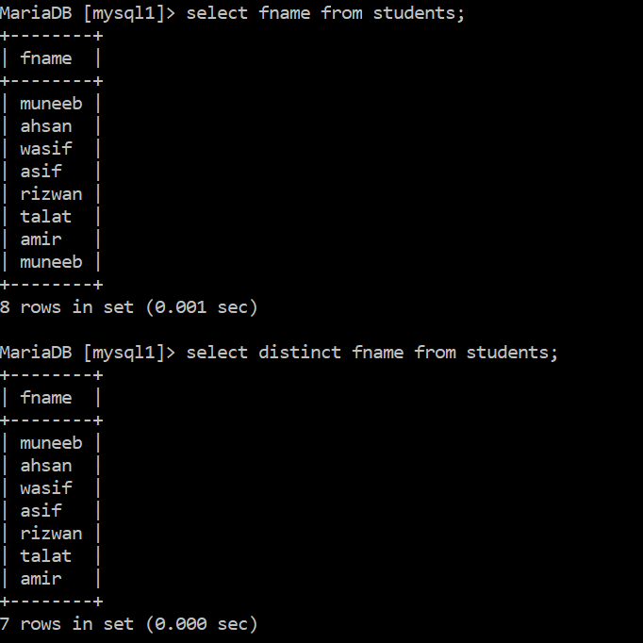

Order:



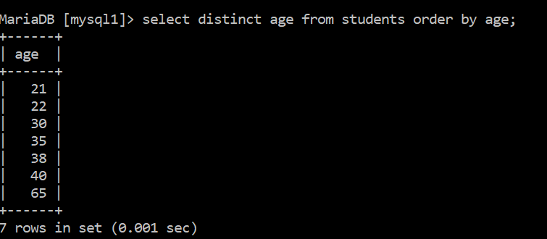

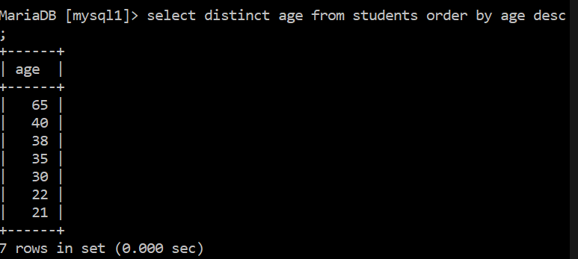

Limit:



Like Operator:

It is something like that person name starts from m etc



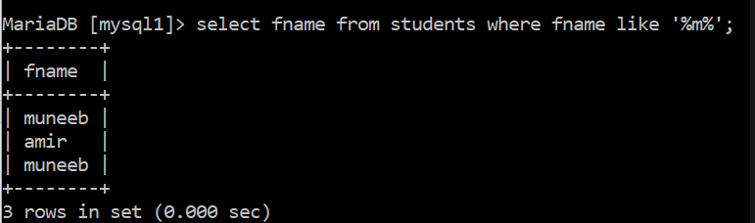

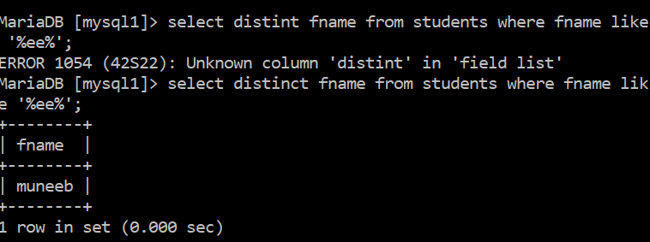

Count, min, max, avg, sum



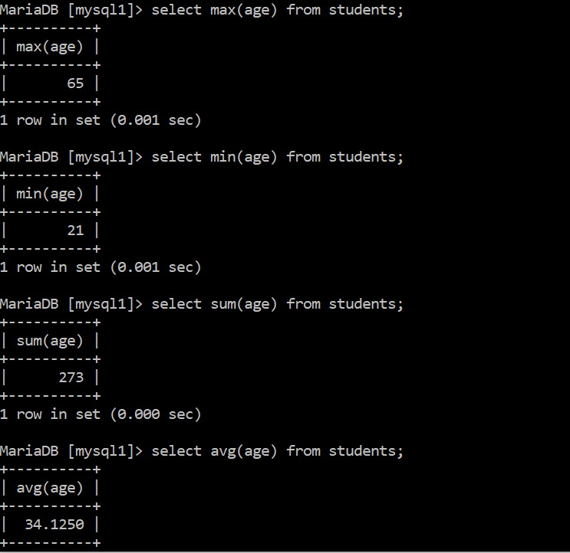

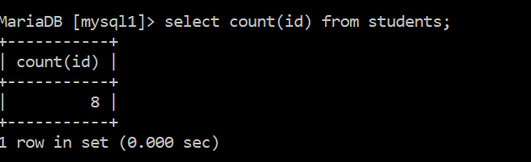

Logical operators:



Equal to and not equal to (== or !=):

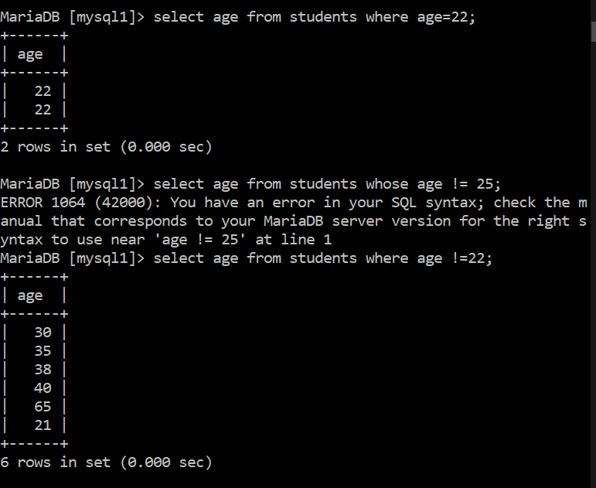

Greater than and less than

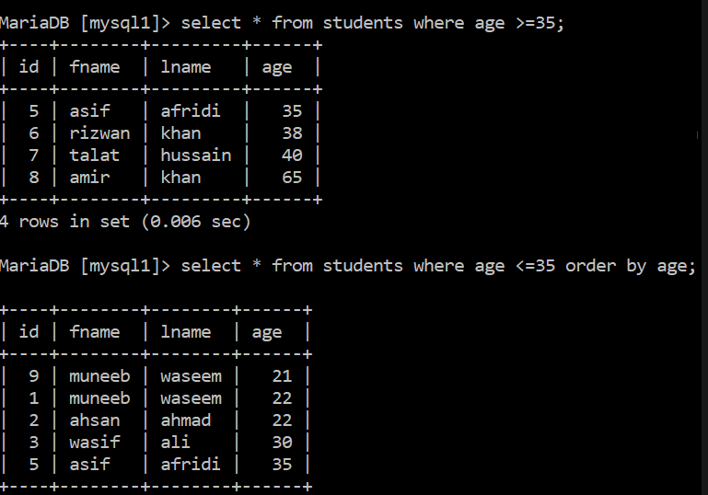

OR (||) and IN:

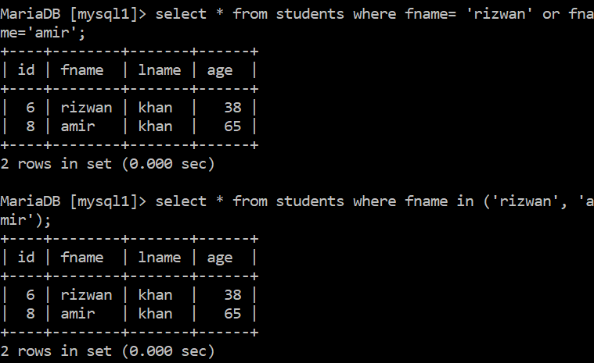

Between and && (both same):

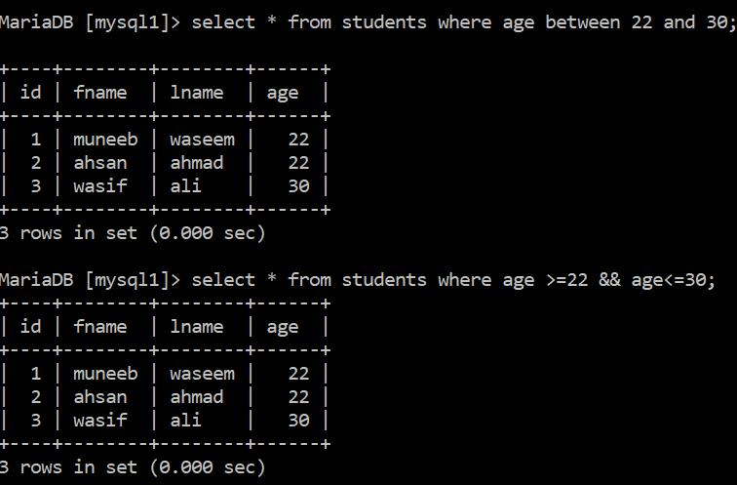

Not between:



Concatenation:



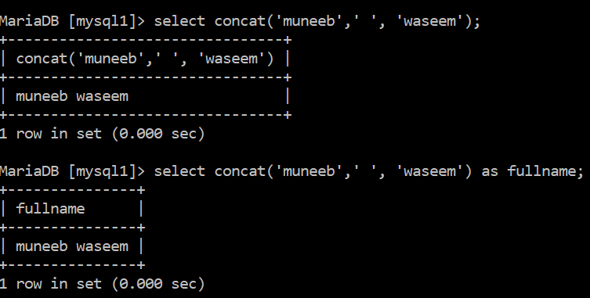

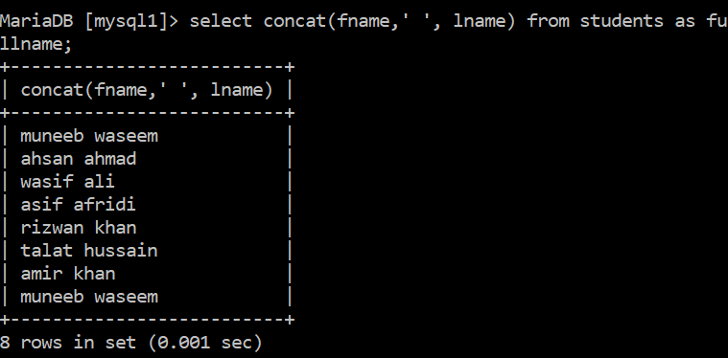

Reverse:

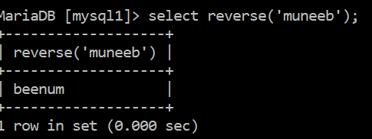

Charlenght, lowercase and uppercase:

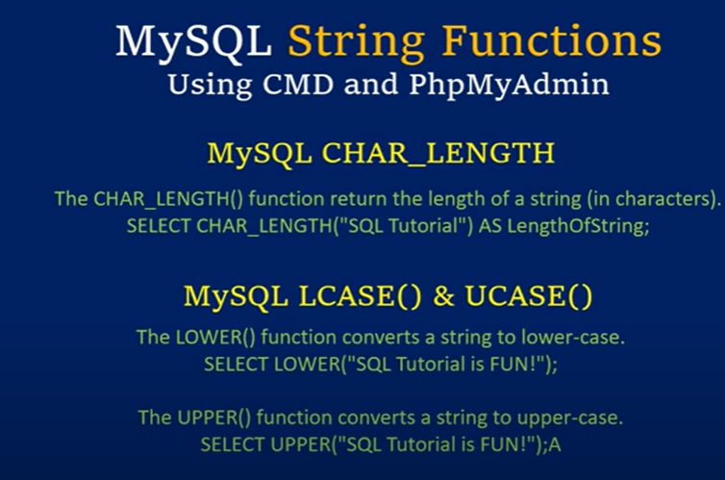

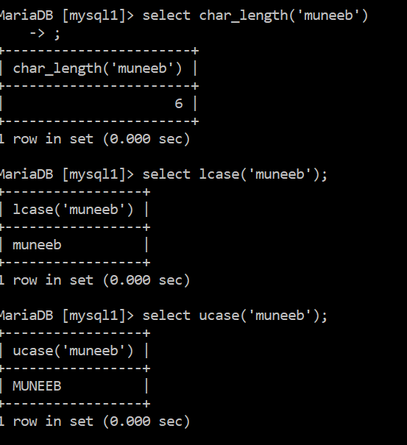

Date time:

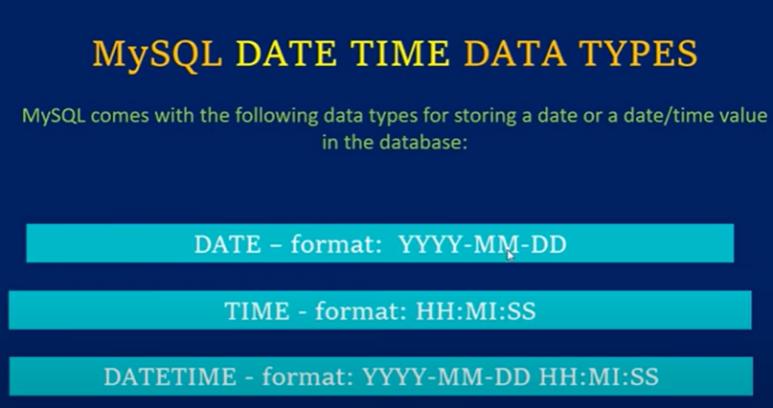

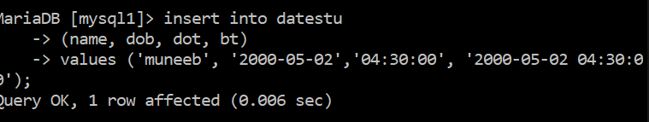

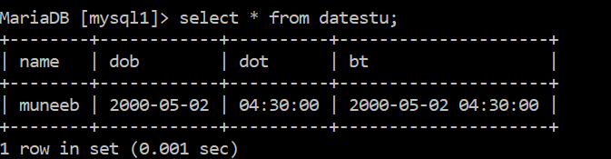

Date time funcitons:

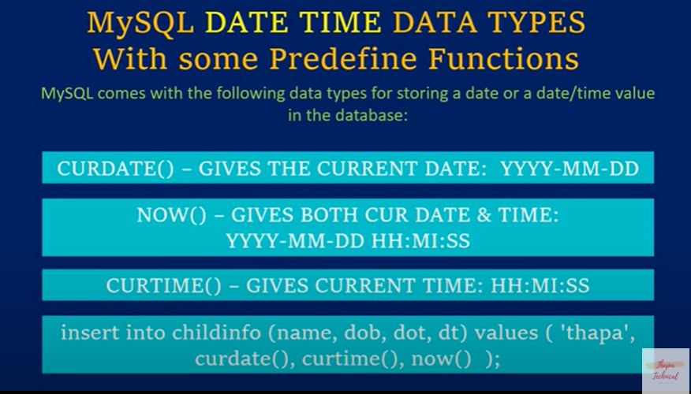

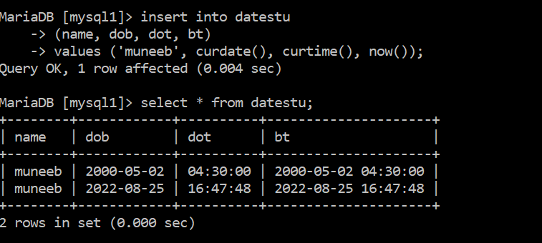

Foreign key:

Use primary key of one table to create link or relation between two tables by using primary key of one table into another table of same database

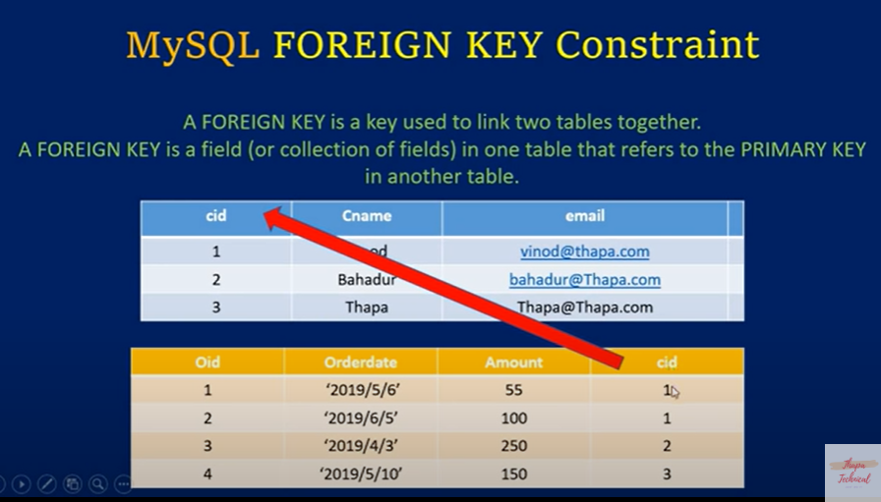

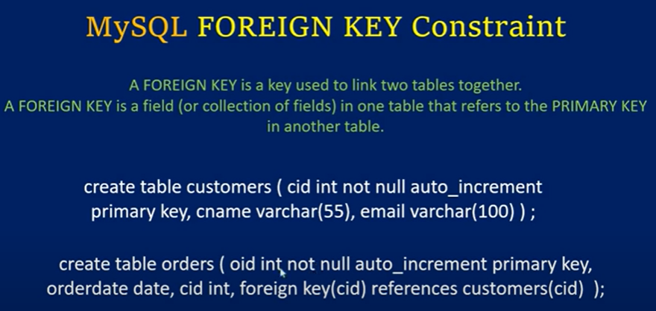

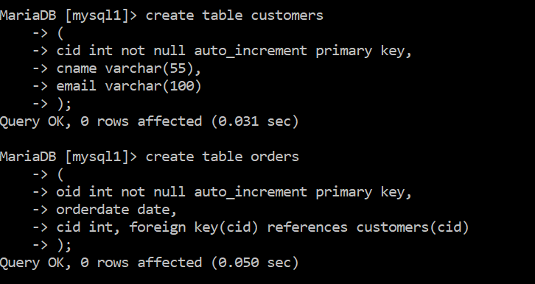

Orders table has cid of table customers, can be verified below as cid is mutual (mul)

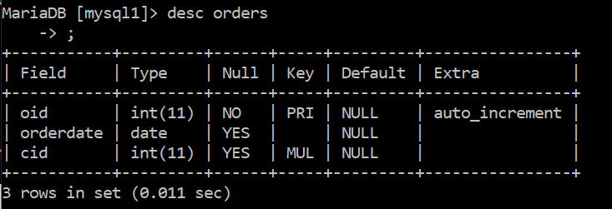

Now inserting data into tables:

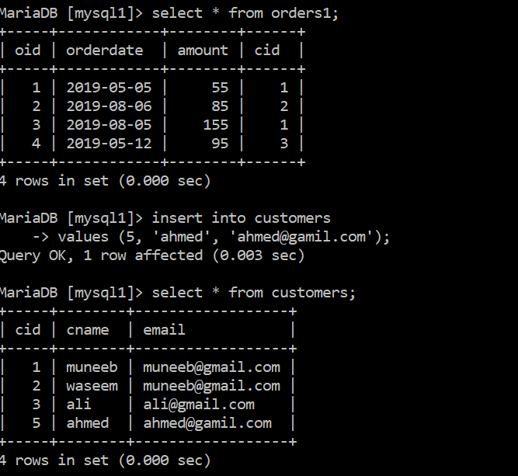

We need to check customer Muneeb has ordered when and of which amount etc, means both are different table for now, so we need to join them

JOIN:

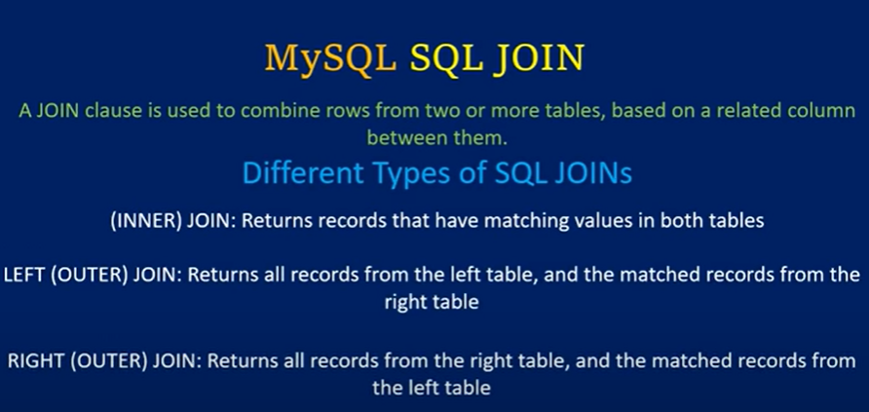

We need to join above two tables customers and orders1

Inner join:

Join by common values in both tables

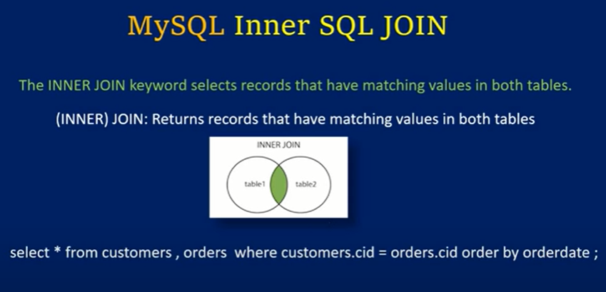

Without join (inner join) where:

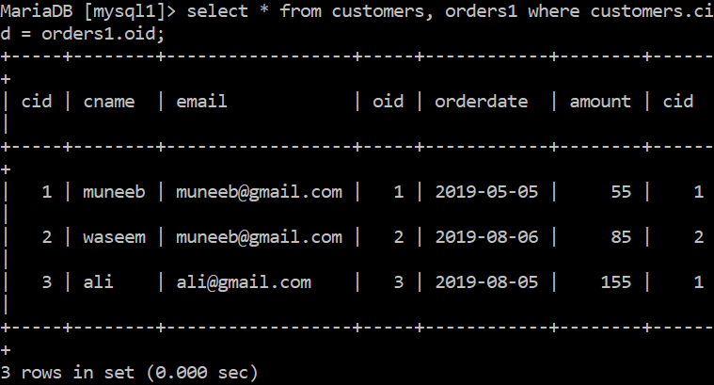

With join (inner join):

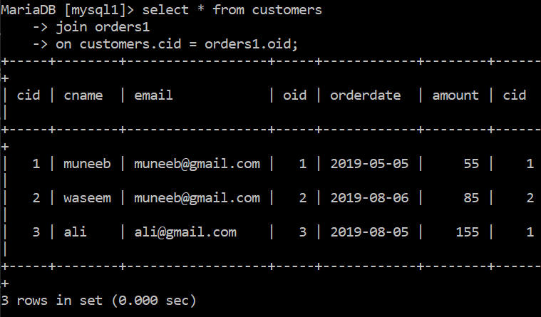

Similarly if we want cname, orderdate and amount after joinng then,

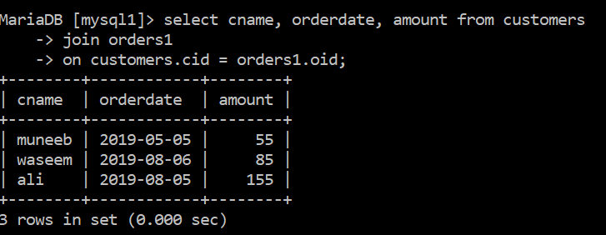

Left join:

All data from table1 and common between table 1 and 2



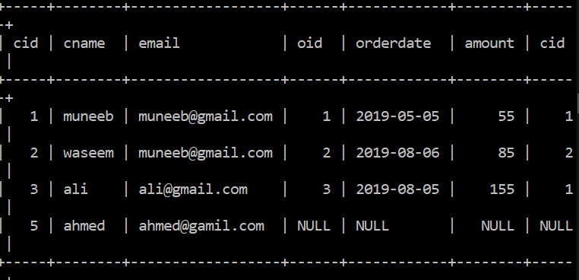

Getting all columns from left table (customers) and common part between customers and orders1

Right join:

Opposite of left join, all fields or columns from right table (orders1) and common between left (customers) and right table (orders1)

